Lab 3: Digital Logic Gates

1 Introduction
The purpose of this assignment is to study the basic logic gates: AND and NOR.

2 Equipment Required
Digital Logic Trainer
1 each, 7402 and 7408 integrated circuits

3 Instructions
3.1 Connect the 74LS08 AND gate as shown in Fig 1.1. Note that Vcc and GND pins connections are not shown on logic diagrams, but you must be sure to connect them.
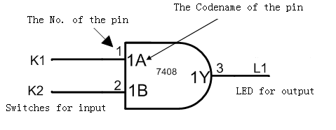
Fig. 1.1 Experimental AND gate circuit

3.2 Then you will verify the AND operation by setting inputs A and B to each set of logic values listed in the Table 1.1. Record the LED (L1) state observed and convert the LED state to a logic level. Use
LED OFF (unlighted) = 0 and LED ON (lighted) = 1

Table 1.1 AND gate circuit experimental results
Data Switches |  | Output Led Monitor  (ON/OFF) | Output Logic Level  (0/1)
k1 | k2 | Output Led Monitor  (ON/OFF) | Output Logic Level  (0/1)
0 | 0
0 | 1
1 | 0
1 | 1

3.3 Connect the 74LS02 NOR gate as shown in Fig 1.2. Do not forget the power supply connections.
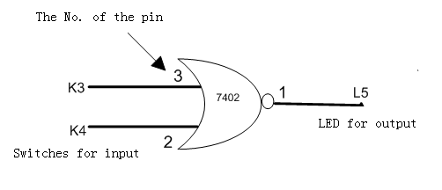
Fig. 1.2 Experimental NOR gate circuit

3.4 Then you will verify the NOR operation by setting inputs A and B to each set of logic values listed in the Table 1.2. Record the LED (L5) state observed and convert the LED state to a logic level.

Table 1.2 NOR gate circuit experimental results
Data Switches |  | Output Led Monitor  (ON/OFF) | Output Logic Level  (0/1)
K3 | K4 | Output Led Monitor  (ON/OFF) | Output Logic Level  (0/1)
0 | 0
0 | 1
1 | 0
1 | 1

4 Knowledge Gains from Experiment

